Wiley Blevins

Keynote
BE THE CHANGE
Fine-Tuning Instruction from the Inside-Out and Outside-In
Examine ways to significantly affect instructional practice whether you are a teacher or administrator. Wiley will address a range of topics from being a teacher-researcher to how principals and district staff can differentiate PD to engage and accelerate teacher learning and maximize growth.

Breakout Session
A FRESH LOOK AT PHONICS
7 Ingredients for Success and 10 Common Causes of Failure
Wiley will share his work with districts over the past five years in which he has been comparing instructional materials, teacher practices, district policies, and test scores to determine where missteps are taking place.

Wiley Blevins is an early reading specialist who holds a M.Ed. from Harvard.
A former elementary school teacher in both the U.S. and South America, Wiley has written and edited many phonics and reading materials. He is the author of the best-selling Phonics from A-Z, Teaching Phonics and Word Study in the Intermediate Grades, Phonemic Awareness Activities for Early Reading Success, Teaching Students to Read Nonfiction, and others. He lives in New York City.
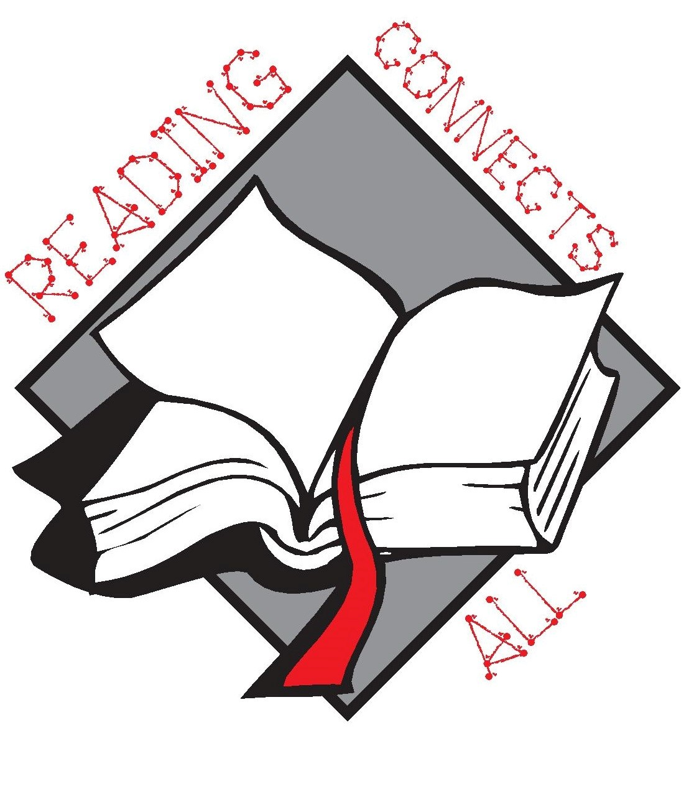
West Virginia Reading Association
60th Annual Conference
November 19-20, 2015

The Greenbrier Resort
White Sulphur Springs, West Virginia

