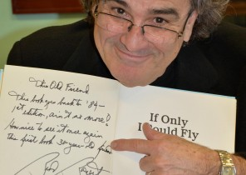
Brod Bagert
Brod’s workshops provide teachers with a framework to use the power oral performance to produce fluent readers, competent writers, and confident learners. Brod’s techniques are novel, delightfully simple, often startling, and immediately effective. His workshops are crafted to then provide teachers with the skills and the texts they need to create a next-generation, fully-functional, cross-curriculum classroom.
7:30-8:45 Authors Breakfast: Rambo Teacher
Friday 10:00-10:45 Governors Hall: A Chorus of Voices: The Instructional Power of Poems Written in the Voice of Your Students
In an entertaining and sometimes raucous performance, Brod recites poems in a variety of voices: A snack-crazed five-year-old, a nine-year-old expressing angry frustration in a letter to a forgetful tooth fairy, and an in-your-face sixth grade girl laying down the law to her male classmates; a performance that becomes the background against which Brod explores the usefulness of poems written in multiple voices to achieve a variety of instructional objectives: oral fluency, writer’s voice, and emotionally engaged relationship with the written word.
3:30 p.m. -4:15 p.m.: Closing Keynote- “The Overpowering Muse”: Be the Teacher you dreamed of and still get those test scores you need!

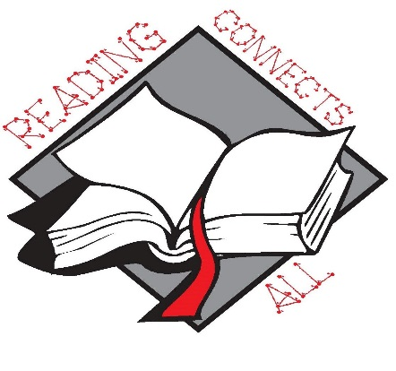

West Virginia Reading Association
60th Annual Conference
November 19-20, 2015

The Greenbrier Resort White Sulphur Springs, West Virginia

