West Virginia Reading Association
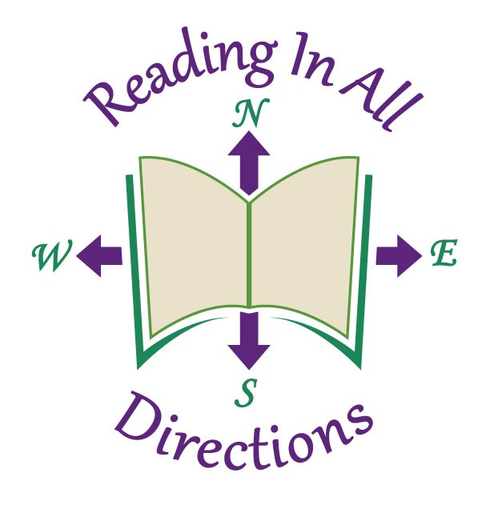
Call for CONFERENCE HOSTESSES OR HOSTS

Dear Colleague:
Thank you for volunteering to be a conference hostess or host. To be a conference hostess or host, you must register and have paid to attend the conference. As a conference hostess or host, you will be an ambassador for the West Virginia Reading Association. Your duties will be to welcome our conference guests, give directions, and answer questions.
As an association, we do not wish to take away from your valuable conference experience; therefore, please provide the following information to assist us in assigning you a hostess or host time slot, which best suits your conference schedule. Check all that apply.
_____Thursday, November 16, 2017 AM; _____Thursday, November 16, 2017 PM
_____Friday, November 17, 2017 AM; _____Friday, November 17, 2017 PM
_____I am flexible. Please schedule me whenever the WVRA needs me.
_____I am a WVRA Executive Board Member. Do not schedule me during Board functions.

NAME:___________________________________________________________________________________
(As it is to appear in the conference program)

Mailing Address:__________________________________________________________________________

City:_________________________________________; State:________; Postal Zip Code:_______________

E-Mail Address:___________________________Preferred Telephone Number: (AC_____)____________

Best times to contact me, only if necessary__________________________________________________

Please return this form by either mail or e-mail, on or before August 1, 2017 to

Jone Hersch
P.O. Box 7
Barrackville, WV 26559
joneh2@aol.com

